Pet request form
Residential Tenancies Act 1997, section 71B

Information for tenants and landlords
Tenants must use this form to ask their landlord for consent to keep a pet at the rented premises. Landlords can only refuse a pet request if the Victorian Civil and Administrative Tribunal (VCAT) orders it is reasonable to do so.
A pet means any animal except an assistance dog (a dog that is trained to perform tasks that help a person with a disability to reduce the effects of their disability).

Information for the tenant
Complete a separate form for each pet you want to keep and give the completed form/s (including this information page) to your landlord. Keep a copy of the form and the details of how you gave the request, for your own records.
Your landlord cannot unreasonably refuse to give you consent. If they want to object to you keeping the pet, your landlord will need to apply to VCAT within 14 days (starting the day after they receive the form) for an order that they may refuse on reasonable grounds. It will be up to VCAT to decide if this type of order should be made. See ‘What can VCAT order?’ below.
If your landlord does not apply to VCAT within this 14-day period, the landlord’s consent is taken to be granted. It may take several days for you to receive a copy of any VCAT application.

Information for the landlord
If you consent to this pet request, it is recommended that you notify the tenant in writing. Tick the relevant box in section 6 and send the form back to the tenant, keeping a copy for your records.
Under the law, you must not unreasonably refuse consent for a tenant to keep a pet on the rented premises. If you want to refuse, you must apply to VCAT within 14 days (of the day after you receive this form). VCAT will hold a hearing and consider your application. See ‘What can VCAT order?’ below.
To apply, visit the VCAT Residential Tenancies Hub (vcat.vic.gov.au/RTHub) or call 1300 01 8228.
Complete section 6 of this form, to tell your tenant whether you consent or whether you have applied to VCAT to refuse consent. Send the form back to the tenant, and keep a copy for your records.
If you do not apply to VCAT within the 14-day period, this will mean you have consented to the pet request, even if you have not given consent in writing.

What can VCAT order?
VCAT can order that:
- the tenant may keep the pet on the premises, or
- it is reasonable for the landlord to refuse consent to the pet request, and/or the pet is excluded from the premises.
When making its decision, VCAT may consider:
- the type of pet the tenant wants to keep, or is keeping
- the character and nature of the premises the tenant is renting
- the character and nature of the appliances, fixtures and fittings in the premises
- other relevant laws (for example, if the pet is prohibited by a local council law)
- anything else VCAT considers relevant.
If VCAT makes an order excluding the pet from the premises, the order will include a date for the tenant to comply with the order. If the tenant has not complied with the order within 14 days of that date, the landlord may serve them with a notice to vacate, giving a minimum of 28 days’ notice.

If a tenant keeps a pet without consent
If a landlord reasonably believes a tenant is keeping a pet on the premises without consent, they can apply to VCAT for an order to exclude the pet from the premises. See ‘What can VCAT order?’ above.

Does this form apply to me?
New laws on pets in rental properties commenced on 2 March 2020. Tenants do not need to request consent for pets that were already present in the rented premises before this date.
After 2 March 2020, tenants who want to bring a new pet into the property must use this form to request consent. It does not matter what date the tenancy agreement started.

Help or further information
For more information, visit Pets and renting – Consumer Affairs Victoria website (consumer.vic.gov.au/petsrenting) or call Consumer Affairs Victoria on 1300 55 81 81.
If you want legal advice you can contact one of the community legal organisations listed at Who to go to for help – Consumer Affairs Victoria website (consumer.vic.gov.au/whotogoto).
Information about renting is available in other languages at Other languages – Consumer Affairs Victoria website (consumer.vic.gov.au/languages).

Telephone Interpreter Service
If you have difficulty understanding English, contact the Translating and Interpreting Service (TIS) on 131 450 (for the cost of a local call) and ask to be put through to an Information Officer at Consumer Affairs Victoria on 1300 55 81 81.
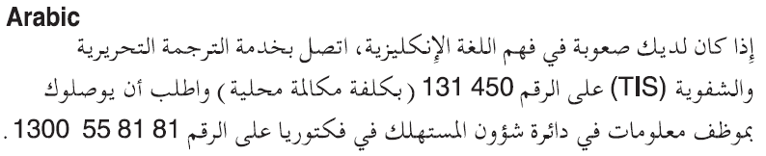
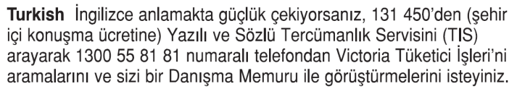
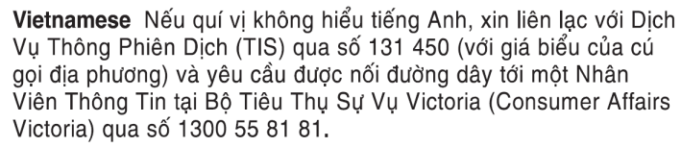
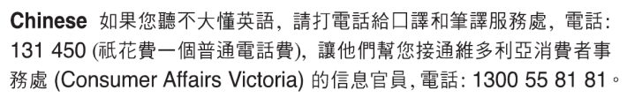
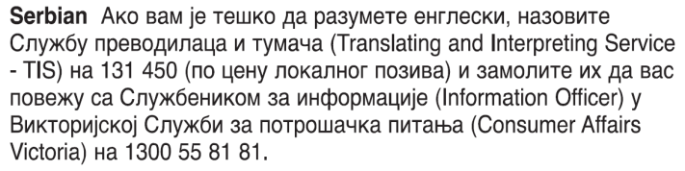
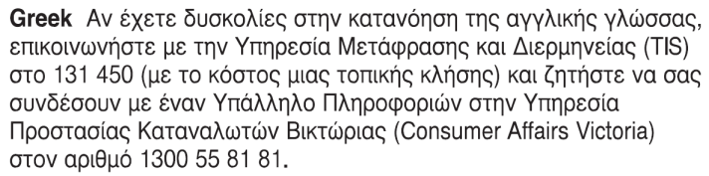
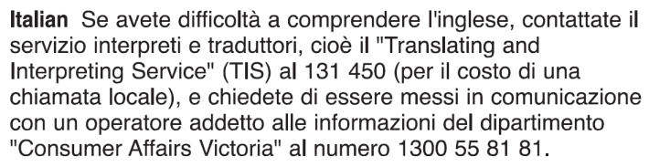

Pet request form

1 Tenant details
Tenant/s name/s:
Address of rented premises:
Tenant/s address for serving documents (can be email address if tenant has consented to electronic service):

2 Landlord details
Landlord/s name/s:
Landlord/s address for serving documents (can be email address if landlord has consented to electronic service, and can be agent’s address):

3 Pet details
I am asking to keep the following pet at the rented premises.
Complete a separate form for each pet. If you do not yet have a specific pet, complete as much information as you can about the kind of pet you intend to keep at the rented premises.
Animal type (including breed and species if known):
Pet name (if known):
Identifying details (if known – e.g. registration number, microchip number, sex, fur colour/length, other features):
Other information you would like to share about the suitability of the pet being kept on the premises:
You do not have to provide other information, but it may help the landlord to make an informed decision. This could include, for example:
- information about the pet’s age, size, temperament, training or other characteristics
- whether the premises is suitable for keeping this type of pet (e.g. size of property, outdoor areas)
- whether the pet is permitted under the local council by-laws
- whether you intend to keep the pet inside and/or outside, or in an appropriate enclosure.
Further details are attached to this form (e.g. photo of pet, photo of enclosure, other information):
Yes:
No:
Description of attachment/s:

4 Service details
This form will be given on (date):
The form will be given (method of delivery):
personally (for example by hand)
by post
Post method (e.g. regular, priority, express, registered)
Delivery time (in days)

email (if the landlord has consented to receive notices this way)
Landlord’s email address (can be an agent’s):
The 14-day period for the landlord to apply to VCAT if they want to refuse consent to the pet request begins the day after the landlord receives the form.
- If you send this form by post, you must take into account the extra days it takes for the form to be delivered. Keep a clear record of the date you posted the form, and any evidence such as a registered post receipt. For information on Australia Post mail delivery options and times, visit the Australia Post website (auspost.com.au).
- If you send this form by email, the provisions of the Electronic Transactions (Victoria) Act 2000 apply. For legal purposes, the time when a document is received is when it can be retrieved from the email address the recipient nominated.

5 Signature of tenant
Signature/s of tenant/s
Name/s of tenant/s
Date of signature/s

6 Landlord’s consent
(To be completed by landlord – check the appropriate box)
I consent to the pet being kept at the rented premises
OR
I have applied to VCAT to refuse consent to this request
VCAT proceeding no.
Signature/s of landlord/s
Name/s of landlord/s
Date of signature/s

